**NAAN MUDHALVAN – GUIDED PROJECT** 

**DOCUMENTATION**

|  |  |
| --- | --- |
| DATE | 31 OCTOBER 2023 |
| TEAM MEMBERS WITH NM ID | 1. AJITH M -  2254C21E6452122B02C43C40D5D391AD 2. AKSHAY G L -  01A66A8FE7968628A6D46EEA29FF9EEC 3. ANITHA S -   7214428F10D584FAB5A41BC468B4B1DD   1. ANURITHI GANDHI K -  17598E31D5823FF8EB849BE7E8FD677E 2. VIGNESH K - 9BD8002F47E3D3C96B448A48B7B0B825 |
| PROJECT NAME | DRUG TRACEABILITY |
| COLLEGE NAME | ALAGAPPA COLLEGE OF TECHNOLOGY, ANNA UNIVERSITY |

**INTRODUCTION:**

**1.1 Project Overview:**

For many years, pharmaceutical organizations have battled to trace products across the supply chain. This shortcoming has made it easier for counterfeiters to introduce counterfeit pharmaceuticals onto the market. To solve the challenge, a new method for tracking and tracing medications is needed. Researchers believe blockchain can provide the technological underpinning for such a system because it can track legal pharmaceuticals and assist prevent the circulation of counterfeit ones. Counterfeited pharmaceuticals and unapproved medicines are dangerous and cause harm to patient life, owing to several causes such as its ineffectiveness, contamination, and inappropriate dose.

**1.2 Purpose:**

The major challenge in handling this is the identification of the counterfeited product due to their similarity to the authentic drugs. Counterfeiting of drugs has become high-volume, high-profit business to the counterfeiters in the 21st century. Blockchain is an electronic cryptographic ledger that has a decentralized network model, here the information is not stored in one database, but the information is distributed and synchronized throughout the supply chain. Since counterfeiting of drugs is increasing globally, pharmaceutical companies are adapting blockchain technology to prevent counterfeiting. The supply of medicines is from manufactures to wholesalers, distributors, and pharmacy stores before it is purchased by customers; the counterfeiters come in between this supply chain and thus fake medicines get supplied and distributed. In this chapter, we are introducing blockchain-based solution “Drug-chain” to improve on the end the end transparency of the drug in supply chain using quick response (QR) code. The authentication of the stakeholders using private and public key is proposed to avoid the misuse of QR code in drug counterfeit. The proposed solution resolves the issues of drug supply chain by bringing the transparency, traceability, security, and authenticity of the data.

**LITERATURE SURVEY:**

**2.1 Existing Problems:**

**LIMITED INFRASTRUCTURE AND PRODUCTION CAPABILITIES:** Major Pharmaceutical companies does not invest and establish production units in developing countries due to geopolitics, market inaccessibility and government instabilities. They are more focused on manufacturing and circulation of branded medicines in developed countries like USA and Europe due to per capita income and pricing monopoly. Developing countries faces major challenges on pharmaceutical industries investment due to poor infrastructure and lack of government funds for research and infrastructure improvements. Existing pharmaceutical units are struggling to meeting global standards due to need of heavy investments in new production and packaging machineries. Digital pharmaceutical products traceability provisions require additional space in manufacturing units for specialized packaging equipment’s to print the unique identifier in all packaging levels, label grading systems, barcode printer and vision systems. This setup needs huge financial investment for manufacturers. Wholesaler and dispenser also need to invest on drug scanner and specialized software which must connect to centralized database for verification. Since developing countries does not have sufficient infrastructure so implementing digital drug traceability is a question.

**UNSECURE AND UNRELIABLE TECHNICAL INFRASTRUCTURE FOR DIGITAL DRUG TRACEABILITY:** Technology advancement is another main challenge in developing countries for authenticating and tracing pharmaceutical products digitally. In recent years, some developed countries like US and Europe have adopted serialization regulation under which drug manufacturer require to print a unique identifier printed with the 2D barcode on individual drug unit. This unique identifier is key source for authenticating drug and tracing its origin of manufacturing. Printing unique identifier and keeping its key data in repository required special packaging equipment, tamper proof seals and global traceability software. The entire setup to serialize drugs for digital traceability required huge investment and developed infrastructure (secure network, high speed internet, skilled resources, and fully digital warehouses). Majority of pharmaceutical manufacturers consider this traceability provision as additional investment which may increase drug cost. It has been noticed that printing unique identifier in drug pack is not sufficient for checking drug authenticity and traceability. For real time traceability and validating authenticity, all stakeholder’s system should be connected to each other with a centralized cloud system (EU-FMD model for Europe). Due to lack of technical system integration for validating authenticity drugs digitally, criminals or counterfeit manufacturers can easily copy the product unique identifier and supply into the markets. India is leading manufacturer and exporter of Generic drugs. On 10 January 2011, Directorate General of Foreign Trade (DGFT), issued a public notice announcing all pharmaceutical drugs exporter must implementation of a track and trace system for serialization as per GS1 standards. Under this notice, all export pharmaceutical consignments should be serialized at various packaging levels using GS1 barcode standards. Drug manufacturers in India faced grave challenges to implement track and trace solutions due to non-readiness of traceability technologies aligned with DGFT requirements. Many manufacturers had old packaging equipment’s which were not capable of encoding serialization data in packaging hierarchy. India’s DGFT regulation also made obligatory for manufacturer to upload Serialization data in DAVA portal (centralized database) in specific format. Due to limited technical capabilities of DAVA portal and its irregular operational functionalities, drug manufacturers and exporter were facing custom issues. The main cause was DGFT requires the use of a product numbering scheme that is inconsistent with global data standards. As a result, manufacturers are forced to choose between changing their entire numbering scheme— a cost that cannot be justified—and applying multiple product numbers to packages. The latter has caused significant operational challenges in countries of import and slowed or stopped the distribution of pharmaceuticals made in India. The drug manufacturer and exporter faced key challenges of portals irregular operational, drug. Another major issue is the availability of Internet in every part of developing countries for drug traceability and authenticity. Digital drug authentication and traceability is completely depending on internet availability and connectivity with governments centralized database. Due to unavailability of basic infrastructure like communication, radio frequency and communication towers, it is very difficult to provide internet connectivity and secure network to drug dispensers in villages and remote areas.

**AMBIGUOUS REGULATIONS:** Regulatory obligation plays a vital role to implement track and trace system for traceability. Developed countries like US in 2018 and Europe in 2019 implemented serialization compliance successfully for drug traceability. Before making digital traceability an obligatory regulation, DSCSA a drug controlling body of FDA runs pilot programs with joint initiative of drug manufacturers, wholesale distributors and community pharmacists. [10] Joint pilot programs are very important to understand current industries status and challenges, stakeholders’ capabilities and improvement require to implement regulations.

**2.2 Reference:**

|  |  |  |
| --- | --- | --- |
| **S.NO** | **Paper Name** | **Authors** |
| 1 | Challenges for Implementing Pharmaceutical Drugs Traceability in Developing Countries | Shambu Sarkar |
| 2 | A Blockchain based approach in healthcare supply chain | **Hmad Musamih, Khaled Salah, Raja Jayaraman, Junaidarshad ,Mazin debe Yousof al-Hammadi and Samer Ellaham** |
| 3 | Drug Traceability using Blockchain | Satish Polshettiwar , Shankar Mali , Nisha Kamble |
| 4 | A Semantic Blockchain based system for Drug Traceability | Maroua Masoudi, Thamer Mecharnia, Redouane Bouhamam, Hajer Bazaaoui Zhgal, Chirine Ghedira, Vlado Stankovski |

**2.3 Problem Statement Definition:**

Blockchain allows the tracking of drug movements all the way from manufacturer to the patient’s doorstep. This helps prevent counterfeit drugs from entering the supply chain and improves drug traceability.

By using blockchain technology, the pharmacy industry can ensure a secure and transparent supply chain, which helps to eliminate the entry of counterfeit medicines into the market. Since blockchain technology tracks every drug’s movement from the manufacturer to the patient’s doorstep, it becomes easy to trace the drug’s origins and detect any signs of tampering or counterfeiting.

Each time a new transaction occurs in the supply chain, it’s added to the blockchain. This creates an immutable record that cannot be altered.

This record includes details like the:

* Date and time of the transaction,
* Parties involved
* Location of the transaction.

So any fraudulent activity can be detected quickly, and the drug can be traced back to its source.

As counterfeit medicines pose a significant threat to public health, ensuring drug traceability using blockchain technology can help prevent these dangerous drugs from entering the supply chain.

**IDEATION & PROPOSED SOLUTION:**

**3.1 Empathy Map Canvas:**

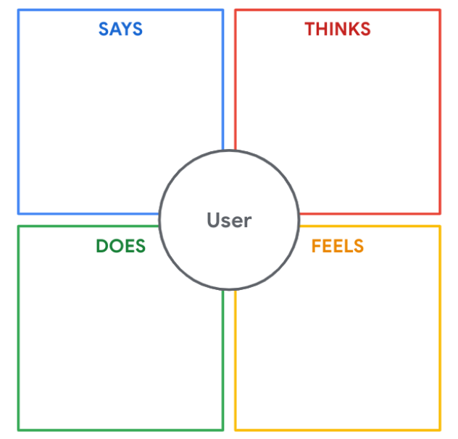

Solution to drug traceability gives the satisfaction of a responsible citizen of being able to help in the intricate care unit of health care and to safeguard the information of drugs being supplied all around.

Blockchain poses to be the best solution to address the issue of drug traceability. It is able to keep track of several products and its movement simultaneously.

Being a large scale manufacturer and to reach a wider population of consumers, it is extremely difficult to keep track of all the movements for a variety of drug produced.

The safety of a consumer lies in the systematic control of the drugs being delivered all around among the consumers. This is one of the prime factor to be considered

**3.2Ideation & Brainstorming:**

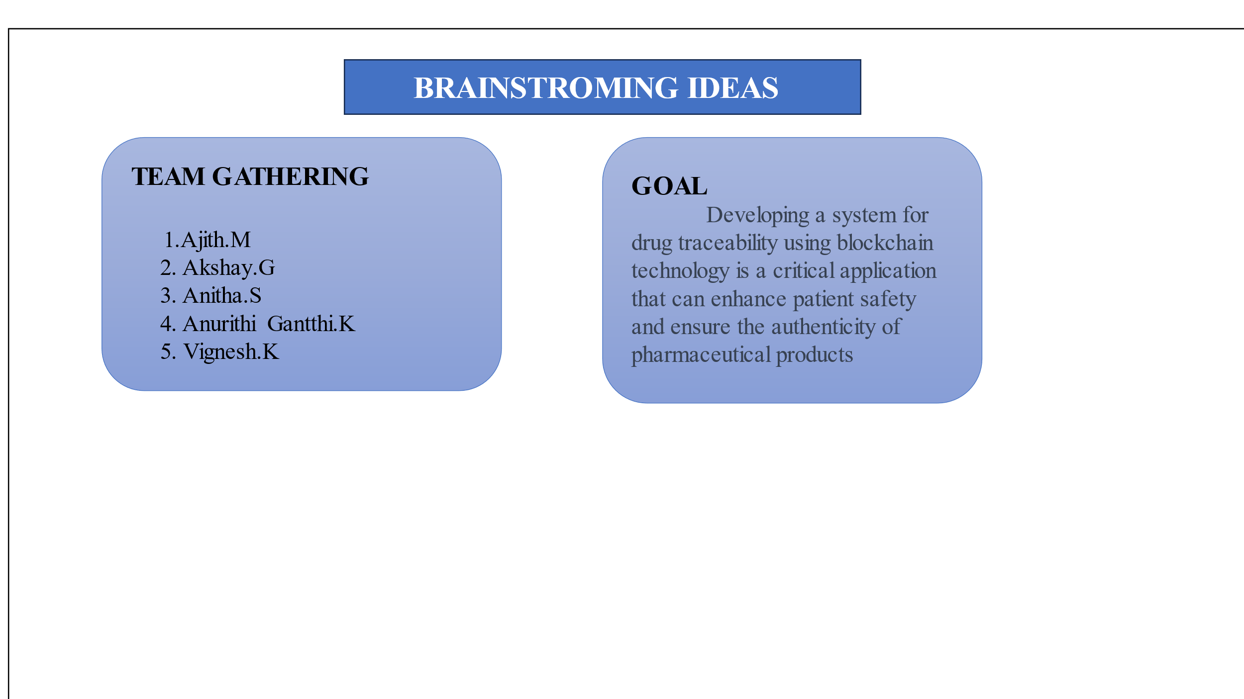

**CONCLUSION:**

The areas which are to be focused on are listed below:

* + 1. Data input mechanism
    2. Smart contracts
    3. Data analysis
    4. Global reach
    5. Feedback mechanism

**REQUIREMENT ANALYSIS :**

**FUNCTIONAL REQUIREMENT:**

The functional requirements of this project are Visual Studio Code, one remix ID platform (node.js connector), file explorer, meta mask chrome extension, and a source code file.

**Drive link of the source code:** <https://drive.google.com/file/d/1GxEgITHHdQ1LeL4CPv50Y7-tD_EGcRlg/view?usp=sharing>

**NON-FUNCTIONAL REQUIREMENT:**

The project should have an intuitive and user-friendly interface to ensure ease of use. It should be highly available and reliable, with minimal downtime for maintenance or updates. It should be scalable to handle increased data and user loads over time.

**PROJECT DESIGN:**

**5.1 Data Flow Diagram & User Stories**

**5.1.1 Data Flow Diagram**

**5.1.2 USER STORIES:**

User stories are a useful way to outline the functional requirements of your project from the perspective of end-users and stakeholders.

**Pharmaceutical Manufacturer**: As a pharmaceutical manufacturer, I want to record each drug's production details on a blockchain to ensure transparency and traceability. This helps prevent counterfeit drugs, comply with regulatory requirements, and boost consumer confidence in the authenticity of our products.

**Distributor:** As a pharmaceutical distributor, I need access to a blockchain system that allows me to verify the authenticity of incoming drug shipments quickly. This ensures that I only distribute genuine products, maintaining the integrity of the supply chain and safeguarding patient safety.

**Pharmacist:** As a pharmacist, I want a user-friendly blockchain app to easily authenticate the drugs I dispense, reducing the risk of selling counterfeit medications and ensuring patients receive safe and effective treatment. **Regulatory Authority**: As a regulatory authority, I require a blockchain-based system to monitor and enforce compliance with drug traceability regulations. This enhances oversight, minimizes illicit drug distribution, and protects public health.

**5.2 SOLUTION ARCHITECTURE:**

Implement a centralized database or data warehouse that serves as the primary repository for all educational data, including student records, assessment results, attendance, and institutional performance data. This centralization ensures data consistency and accessibility. Employ robust user authentication and authorization mechanisms to control access to the system. Implement role-based access control, allowing administrators, educators, students, and parents to access specific data and functionalities based on their roles. Develop data integration processes and ETL workflows to consolidate data from various sources. These processes should include data mapping, transformation, and validation to ensure data accuracy before it is stored in the central repository. Build a data analytics and reporting engine that allows users to create, customize, and schedule reports and visualizations. Implement data analytics tools to derive meaningful insights from the educational data, aiding data-driven decision-making.

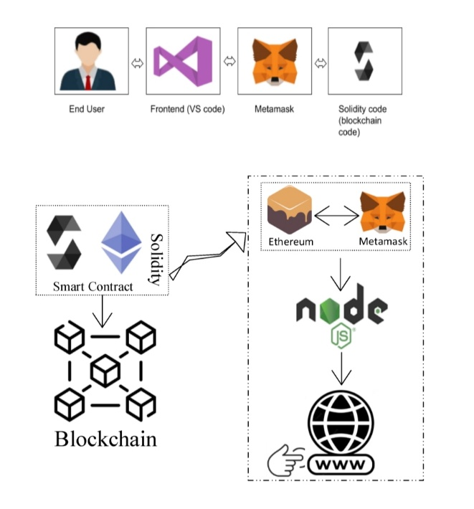

**PROJECT PLANNING & SCHEDULING:**

**6.1 Technical Architecture:**

Develop a responsive web-based frontend using technologies like HTML, CSS, and JavaScript. Implement a user-friendly interface that allows administrators, educators, students, and parents to access the system through web browsers. Create a backend server using a framework like Node.js, Django, or Ruby on Rails. This server will handle user authentication, data processing, data integration, validation, and communication with the database. Implement a relational database or data warehouse to store and manage educational data. Use database management systems like PostgreSQL, MySQL, or Microsoft SQL Server. Ensure that the database schema supports data integration and is optimized for efficient data retrieval. Integrate data analytics and reporting tools, such as Tableau, Power BI, or custom-built solutions, into the architecture. These tools should allow users to create, customize, and schedule reports and visualizations based on the educational data stored in the database. Host the application and database on a secure and scalable cloud platform, such as AWS, Azure, or Google Cloud. Implement security measures, including encryption, role-based access control, and firewall configurations. Regularly update and maintain the infrastructure to ensure high availability and reliability.

**6.2 Sprint Planning & Estimation:**

Before each sprint, conduct backlog refinement to review and prioritize user stories. Work with stakeholders to identify and prioritize the most critical features and improvements based on their importance and impact. Ensure that the sprint goal is specific and measurable, making it easier to track progress. Use a relative estimation technique, such as story points or ideal days, to estimate the effort required for each user story. Involve the development team in the estimation process to gain a consensus on the effort require in a sprint planning meeting, select a set of user stories from the prioritized backlog that can be realistically completed in the upcoming sprint. Break down user stories into tasks and define acceptance criteria for each. Used velocity to determine the number of story points or tasks that can be taken into the sprint based on the sprint duration.

**6.3 Sprint Delivery Schedule:**

**Sprint 1 (Duration: 1 week)**

Sprint Goal:

Set up the foundational architecture for the system.

User Stories:

User authentication and role-based access control.

Database schema design for central data repository.

Basic user interface for administrators.

User Story Estimations:

12 story points.

Deliverables:

Authentication system, basic database structure, and administrator login functionality.

**Sprint 2 (Duration: 1 week)**

Sprint Goal:

Implement data integration and validation processes.

User Stories:

Data integration from one data source (e.g., drug records).

Data validation and error handling.

User Story Estimations:

10 story points.

Deliverables:

Data integration module for one data source, validation framework.

**Sprint 3 (Duration: 1 week)**

Sprint Goal:

Enhance data management and analytics.

User Stories:

Complete data integration for additional data sources (e.g., drug manufacturing and dispatch).

Implement basic reporting and visualization features.

User Story Estimations:

15 story points.

Deliverables:

Data integration for additional sources, basic reporting tools.

**Sprint 4 (Duration: 1 week)**

Sprint Goal:

Improve data security and user management.

User Stories:

Implement data encryption and access controls.

User account management features (create, reset password, etc.).

User Story Estimations:

14 story points.

Deliverables:

Enhanced data security and user management capabilities.

**Sprint 5 (Duration: 1 week)**

Sprint Goal:

Enhance the user interface and user experience.

User Stories:

Improve the user interface for drug manufacturers and consumers.

Implement user notifications and communication features.

User Story Estimations:

10 story points.

Deliverables:

Improved user interfaces and communication features.

**7. Coding and solutions:**

const { ethers } = require("ethers");  
  
const abi = [  
 {  
  "inputs": [],  
  "stateMutability": "nonpayable",  
  "type": "constructor"  
 },  
 {  
  "anonymous": false,  
  "inputs": [  
   {  
    "indexed": true,  
    "internalType": "uint256",  
    "name": "drugId",  
    "type": "uint256"  
   },  
   {  
    "indexed": false,  
    "internalType": "string",  
    "name": "drugName",  
    "type": "string"  
   },  
   {  
    "indexed": false,  
    "internalType": "string",  
    "name": "manufacturer",  
    "type": "string"  
   },  
   {  
    "indexed": false,  
    "internalType": "uint256",  
    "name": "manufacturingDate",  
    "type": "uint256"  
   }  
  ],  
  "name": "DrugManufactured",  
  "type": "event"  
 },  
 {  
  "anonymous": false,  
  "inputs": [  
   {  
    "indexed": true,  
    "internalType": "uint256",  
    "name": "drugId",  
    "type": "uint256"  
   },  
   {  
    "indexed": true,  
    "internalType": "address",  
    "name": "from",  
    "type": "address"  
   },  
   {  
    "indexed": true,  
    "internalType": "address",  
    "name": "to",  
    "type": "address"  
   },  
   {  
    "indexed": false,  
    "internalType": "uint256",  
    "name": "transferDate",  
    "type": "uint256"  
   }  
  ],  
  "name": "DrugTransferred",  
  "type": "event"  
 },  
 {  
  "inputs": [],  
  "name": "drugCount",  
  "outputs": [  
   {  
    "internalType": "uint256",  
    "name": "",  
    "type": "uint256"  
   }  
  ],  
  "stateMutability": "view",  
  "type": "function"  
 },  
 {  
  "inputs": [  
   {  
    "internalType": "uint256",  
    "name": "",  
    "type": "uint256"  
   }  
  ],  
  "name": "drugs",  
  "outputs": [  
   {  
    "internalType": "string",  
    "name": "drugName",  
    "type": "string"  
   },  
   {  
    "internalType": "string",  
    "name": "manufacturer",  
    "type": "string"  
   },  
   {  
    "internalType": "uint256",  
    "name": "manufacturingDate",  
    "type": "uint256"  
   },  
   {  
    "internalType": "address",  
    "name": "trackingHistory",  
    "type": "address"  
   }  
  ],  
  "stateMutability": "view",  
  "type": "function"  
 },  
 {  
  "inputs": [  
   {  
    "internalType": "uint256",  
    "name": "\_drugId",  
    "type": "uint256"  
   }  
  ],  
  "name": "getDrugDetails",  
  "outputs": [  
   {  
    "internalType": "string",  
    "name": "",  
    "type": "string"  
   },  
   {  
    "internalType": "string",  
    "name": "",  
    "type": "string"  
   },  
   {  
    "internalType": "uint256",  
    "name": "",  
    "type": "uint256"  
   },  
   {  
    "internalType": "address",  
    "name": "",  
    "type": "address"  
   }  
  ],  
  "stateMutability": "view",  
  "type": "function"  
 },  
 {  
  "inputs": [  
   {  
    "internalType": "uint256",  
    "name": "drugId",  
    "type": "uint256"  
   },  
   {  
    "internalType": "string",  
    "name": "\_drugName",  
    "type": "string"  
   },  
   {  
    "internalType": "string",  
    "name": "\_manufacturer",  
    "type": "string"  
   },  
   {  
    "internalType": "uint256",  
    "name": "\_manufacturingDate",  
    "type": "uint256"  
   }  
  ],  
  "name": "manufactureDrug",  
  "outputs": [],  
  "stateMutability": "nonpayable",  
  "type": "function"  
 },  
 {  
  "inputs": [],  
  "name": "owner",  
  "outputs": [  
   {  
    "internalType": "address",  
    "name": "",  
    "type": "address"  
   }  
  ],  
  "stateMutability": "view",  
  "type": "function"  
 },  
 {  
  "inputs": [  
   {  
    "internalType": "uint256",  
    "name": "\_drugId",  
    "type": "uint256"  
   },  
   {  
    "internalType": "address",  
    "name": "\_to",  
    "type": "address"  
   }  
  ],  
  "name": "transferDrugOwnership",  
  "outputs": [],  
  "stateMutability": "nonpayable",  
  "type": "function"  
 }  
]  
  
if (!window.ethereum) {  
 alert('Meta Mask Not Found')  
 [window.open](https://window.open/" \t "_blank" \o "https://window.open)("[https://metamask.io/download/](https://metamask.io/download/" \t "_blank" \o "https://metamask.io/download/)")  
}  
  
export const provider = new ethers.providers.Web3Provider(window.ethereum);  
export const signer = provider.getSigner();  
export const address = "0xb444263feA078cb7E880da056593969Ac84e1e0e"  
  
export const contract = new ethers.Contract(address, abi, signer)

**8.1 Performance Testing**

|  |  |  |
| --- | --- | --- |
| S.NO | PARAMETERS | SCREENSHOT |
| 1 | Information gathering |  |
| 2 | Extract the zip files |  |
| 3 | Remix IDE exploration |  |
| 4 | Open file explorer |  |
| 5 | Local host  (IP address) | **Local: <http://localhost:3000>**  **On Your Network: http://192.168.43.13:3000** |

**Result:**

9.1 Output Screenshot

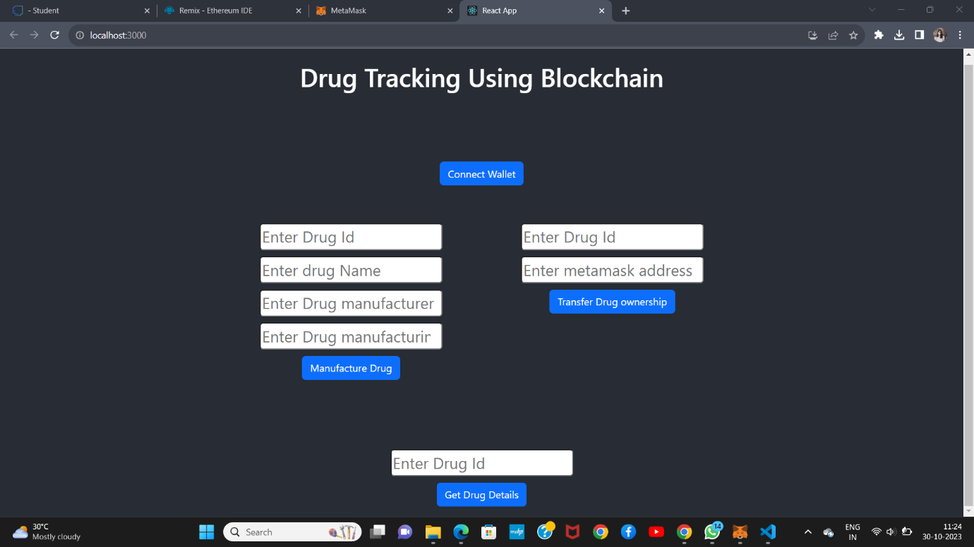

**Advantages**:

1. Transparency and Trust: Blockchain provides a transparent and immutable ledger of transactions, enhancing trust throughout the supply chain. All stakeholders can verify the authenticity of drugs.
2. Security: Blockchain’s cryptographic methods make it extremely difficult to tamper with data, reducing the risk of counterfeit drugs entering the market.
3. Traceability: Every step in the drug supply chain, from manufacturer to consumer, can be traced, ensuring the origin and handling of the product.
4. Efficiency:Smart contracts on blockchain can automate processes, reducing paperwork, minimizing errors, and streamlining logistics.
5. Reduced Counterfeits:By making it difficult for counterfeit drugs to enter the supply chain, patient safety is improved.

**Disadvantages**:

1. Cost: Implementing and maintaining blockchain systems can be expensive. Small manufacturers or distributors may find it cost-prohibitive.
2. Complexity: Blockchain technology can be complex to understand and implement, requiring skilled personnel or third-party providers.
3. Integration Challenges: Integrating blockchain with existing systems can be challenging, and it may take time to achieve seamless interoperability.
4. Data Privacy: Sensitive data about drugs and patients is stored on the blockchain, raising privacy concerns. Proper encryption and access controls are crucial.
5. Scalability: As the number of transactions and participants in the supply chain grows, blockchain scalability can become an issue, leading to slower transaction processing times.
6. Regulatory Compliance Adherence to varying regional and industry-specific regulations can be a challenge when implementing blockchain in the pharmaceutical supply chain.

**Conclusion**:

* Innovative technologies are taken into consideration as a potential component in increasing the efficiency of their supply chain due to the complicated nature of the supply chain and in order to enhance the business processes. One of the most significant sources of big data generation in pharmaceutical enterprise systems for drug traceability is one of these new IoT technologies. Additionally, supply chain management can be offered to the consumer using other IoT and blockchain features including promoting item communication, integrating monitoring devices, data analysis, pharmaceutical drug traceability and using cyberspace. To do this, the enterprise system environment must offer a model that describes the connections between Internet technologies and logistical systems, cloud computing, and physical items. Implementation of blockchain and IoT enabled technologies in pharmaceutical organizations for drug traceability demonstrates that this strategy plays a significant role in enterprise system. It has the satisfaction of customers and at the same time the owners of these industries. It increases organizational efficiency, accelerates audience access to products, ensures the health of products, and prevents energy loss.

**Future scope**:

* The future scope for using blockchain for drug traceability is promising and continues to evolve. Several trends and opportunities in this field include:
  1. Global Adoption: As more countries and regions recognize the benefits of blockchain in drug traceability, there is the potential for global adoption. International standards and collaborations may emerge, enhancing interoperability.
  2. Enhanced Data Sharing: Blockchain can facilitate secure data sharing across the pharmaceutical supply chain. This could lead to improved collaboration between manufacturers, distributors, regulators, and healthcare providers.
  3. IoT Integration: The integration of Internet of Things (IoT) devices with blockchain can provide real-time monitoring of drug conditions, such as temperature and humidity during transportation, further ensuring product quality.
  4. Personalized Medicine: Blockchain can support the traceability of personalized medicine, where drugs are tailored to an individual's genetic profile. This can improve patient outcomes and minimize adverse reactions.
  5. AI and Predictive Analytics: Combining blockchain with artificial intelligence and predictive analytics can help in proactive identification of potential supply chain issues, reducing the risk of counterfeit drugs and shortages.
  6. Improved Pharmacovigilance: Blockchain can help in tracking and reporting adverse drug reactions in real-time, enhancing pharmacovigilance efforts.
  7. Supply Chain Optimization: Blockchain can lead to a more efficient and optimized pharmaceutical supply chain, reducing costs, waste, and fraud.
  8. Regulatory Compliance: Blockchain can simplify regulatory compliance by providing a transparent and auditable record of each drug's journey through the supply chain. This can aid in faster approvals and inspections.
  9. Decentralized Clinical Trials: Blockchain can support decentralized clinical trials by securely managing and sharing patient data, increasing the efficiency of drug development.
  10. Tokenization and Incentives: Tokenized systems and incentive models can encourage participants in the supply chain to adhere to best practices and report issues promptly.
  11. Interoperability: Future developments may focus on enhancing interoperability between different blockchain networks, ensuring a seamless flow of data across various systems.
  12. Smart Packaging: Smart packaging with embedded blockchain technology can provide consumers with real-time information about a drug's authenticity, expiration date, and usage instructions.
* The future of blockchain in drug traceability is likely to involve ongoing advancements in technology and increased adoption, making pharmaceutical supply chains more secure, efficient, and transparent. However, it will also require addressing challenges such as scalability, regulation, and standardization.